Submitted to
DR. ARUN KUMAR S
VELLORE INSTITUTE OF TECHNOLOGY
PATEL YASH VIJAYKUMAR 17BCE0335
SHREYA JAIN 17BCE0455
HARSHITA TIBREWAL 17BCE0683
HUMAN COMPUTER INTERACTION
FINAL REVIEW- HAAR CASCADE FACE RECOGNITION
- Abstract (Should cover – Aim, Objective, Proposed Methodology, Expected Outcome)

Human face identification has been a testing issue in the regions of picture preparing and patter acknowledgment. Another human face location calculation by crude Haar course calculation joined with the refreshed changes are to be examined.First, pictures of individuals are handled by a crude Haar course classifier, almost without wrong human face dismissal (low rate of false negative) yet with some wrong acknowledgment (false positive). Also, to dispose of these wrongly acknowledged non-human faces, a powerless classifier in light of face skin tint histogram coordinating is connected and a dominant part of non-human countenances are evacuated. Next, another frail classifier in view of eyes identification is attached and some leftover non-human appearances are resolved and dismissed. At last, a mouth recognition task is used to the rest of the non-human appearances and the false positive rate is additionally diminished.

With the assistance of OpenCV, test results on pictures of individuals under various impediments and enlightenments and some level of introductions and turns, in both preparing set and test set are done to demonstrate that the proposed calculation is successful and accomplishes cutting edge execution. Besides, it is proficient in view of its effortlessness and straightforwardness of execution.

Programmed discovery of human countenances is the basic front end of any face following and acknowledgment systems,which find and fragment confront areas from recordings or still pictures. There are various face following and acknowledgment applications in zones like reconnaissance and security control frameworks, video conferencing and astute human PC interfaces. Be that as it may, most picture and recordings are confounded and may contain different appearances.

A face identification calculation recognizes the area and size of the considerable number of countenances in a picture. Face location remains a testing undertaking due to varieties in scale, introduction, present, outward appearance, lighting, and camera alignment. There are two principle approaches for distinguishing faces: comprehensive strategies as in, which think about the face as a worldwide question, and highlight based strategy as in, which endeavor to perceive parts of the face and amass them to take an official choice. Different systems can likewise utilize a blend of the two methodologies.

Face discovery is the initial phase in any mechanized framework that tackles issues, for example, confront acknowledgment, confront following, and outward appearance acknowledgment. A few face recognition frameworks have been presented. Location rate and the number of false positives are vital factors in assessing face recognition frameworks. Identification rate is the proportion between the quantity of appearances accurately distinguished by the framework and the genuine number of countenances in the picture.

Amid the most recent decade, the looks into in the territory of face recognition (FD) turned out to be exceptionally dynamic. The reason is the regularly developing noteworthiness of present day uses of this innovation, for example, confront acknowledgment, videoconferences, content-based picture recovery, video reconnaissance, human-PC interface, investigation of face appearances, guests tallying, get to control, and so forth., where the discovery is generally the first and most critical phase of any face preparing. The FD errand is very basic for the people however turns into a significant issue while building up a programmed location framework because of numerous components which influence theface appearance, for example, in-plane and out-of-plane pivots confront looks, impediments, lighting conditions etc.Nowadays more ideal are the appearance-based strategies for confront recognition as far as discovery of legitimacy and speed.

As the need for more elevated amounts of security rises, innovation is bound to swell to satisfy these necessities. Any new creation, venture, or then again improvement ought to be uncomplicated and adequate for end clients with a specific end goal to spread around the world. This solid interest for client inviting frameworks which can anchor our advantages and ensure our security without losing our character in an ocean of numbers, got the consideration and investigations of researchers toward what's called biometrics.
2. Introduction Section
2.1 Back ground of the problem
Until recently, face recognition technology was commonly viewed as something straight out of science fiction. But over the past decade, this groundbreaking technology has not just become viable, it has become widespread. In fact, it’s difficult to read technology news these days without seeing something about face recognition.
Here are some key events in the history of facial recognition:
MANUAL MEASUREMENTS BY BLEDSOE (1960S)
Many would say that the father of facial recognition was Woodrow Wilson Bledsoe. Working in the 1960s, Bledsoe developed a system that could classify photos of faces by hand using what’s known as a RAND tablet, a device that people could use to input horizontal and vertical coordinates on a grid using a stylus that emitted electromagnetic pulses. The system could be used to manually record the coordinate locations of various facial features including the eyes, nose, hairline and mouth. These metrics could then be inserted in a database. Then, when the system was given a new photograph of an individual, it was able to retrieve the image from the database that most closely resembled that individual. At the time, face recognition was unfortunately limited severely by the technology of the era and computer processing power. However, it was an important first step in proving that face recognition was a viable biometric.
INCREASED ACCURACY WITH 21 FACIAL MARKERS (1970S)
In the 1970s, Goldstein, Harmon, and Lesk were able to add increased accuracy to a manual facial recognition system. They used 21 specific subjective markers including lip thickness and hair color in order to identify faces automatically. As with Bledsoe’s system, the actual biometrics had to still be manually computed.
EIGENFACES (LATE 1980S-EARLY 1990S)
In 1988, Sirovich and Kirby began applying linear algebra to the problem of facial recognition. What became known as the Eigenface approach started as a search for a low-dimensional representation of facial images. Sirovich and Kriby were able to show that feature analysis on a collection of facial images could form a set of basic features. They were also able to show that less than one hundred values were required in order to accurately code a normalized face image. In 1991, Turk and Pentland expanded upon the Eigenface approach by discovering how to detect faces within images. This led to the first instances of automatic face recognition. Their approach was constrained by technological and environmental factors, but it was a significant breakthrough in proving the feasibility of automatic facial recognition.

FERET PROGRAM (1993-2000S)
The Defense Advanced Research Projects Agency (DARPA) and the National Institute of Standards and Technology rolled out the Face Recognition Technology (FERET) program beginning in the 1990s in order to encourage the commercial face recognition market. The project involved creating a database of facial images. The database was updated in 2003 to include high-resolution 24-bit color versions of images. Included in the test set were 2,413 still facial images representing 856 people. The hope was that a large database of test images for facial recognition would be able to inspire innovation that might result in more powerful facial recognition technology.

SUPER BOWL XXXV (2002)
At the 2002 Super Bowl, law enforcement officials used facial recognition in a major test of the technology. While officials reported that several “petty criminals” were detected, overall the test was seen as a failure. False positives and backlash from critics proved that face recognition wasn’t quite ready for prime time. One of the big technological limitations at the time was that face recognition did not yet work well in large crowds, functionality that is essential to using face recognition for event security.
FACE RECOGNITION VENDOR TESTS (2000S)
The National Institute of Standards and Technology (NIST) began Face Recognition Vendor Tests (FRVT) in the early 2000s. Building on FERET, FRVTs were designed to provide independent government evaluations of facial recognition systems that were commercially available, as well as prototype technologies. These evaluations were designed to provide law enforcement agencies and the U.S. government with information necessary to determine the best ways to deploy facial recognition technology.
It may seem to some that facial recognition came out of nowhere. But in truth, this technology has been in the works for some time. This post will take a look at the history of face recognition in order to shed light on how this transformative tech came to be, and how it has evolved over time.
2.2 Motivation of the proposed work
Face discovery has picked up a great deal of consideration because of its continuous applications. A great deal of research has been done and as yet continuing for enhanced and quick execution of the face discovery calculation. For what reason is confront location troublesome for a machine? Face discovery isn't as simple as it appears to be because of bunches of varieties of picture appearance, for example, present variety (front, non-front), impediment, picture introduction, enlightenment changes and outward appearance. There are a few enterprises profiting from this innovation. Law authorization offices are utilizing face acknowledgment to keep networks more secure. Retailers are avoiding wrongdoing and savagery. Air terminals are enhancing voyagers' comfort and security. What's more, cell phone organizations are utilizing face acknowledgment to furnish customers with new layers of biometric security. OpenCV contains numerous pre-prepared classifiers for confront, eyes, grin and so on. The XML documents of pre-prepared classifiers are put away in opencv/information/. For confront identification particularly, there are pre-prepared classifiers: Haar Cascade Classifier

2.3 Focus of the proposed work
The focus of the proposed work is to reduce the wrong tagging of the faces present in photo.
The Viola-Jones’ rejection cascade, composed of many boosted classifier groups of decision trees trained on the features from faces and non-faces o rother training objects to be detected. In case of faces, almost all (99.9%) of the faces are found, but many non-faces (about 50%) are wrongly regarded as positive ones. This is feasible, because a sufficiently large number (say 20) of such nodes will yield a false positive rate of only 0.520 § 0.0001% and a face detection rate of
0.99920 = 98%.

Haar Cascade Classifier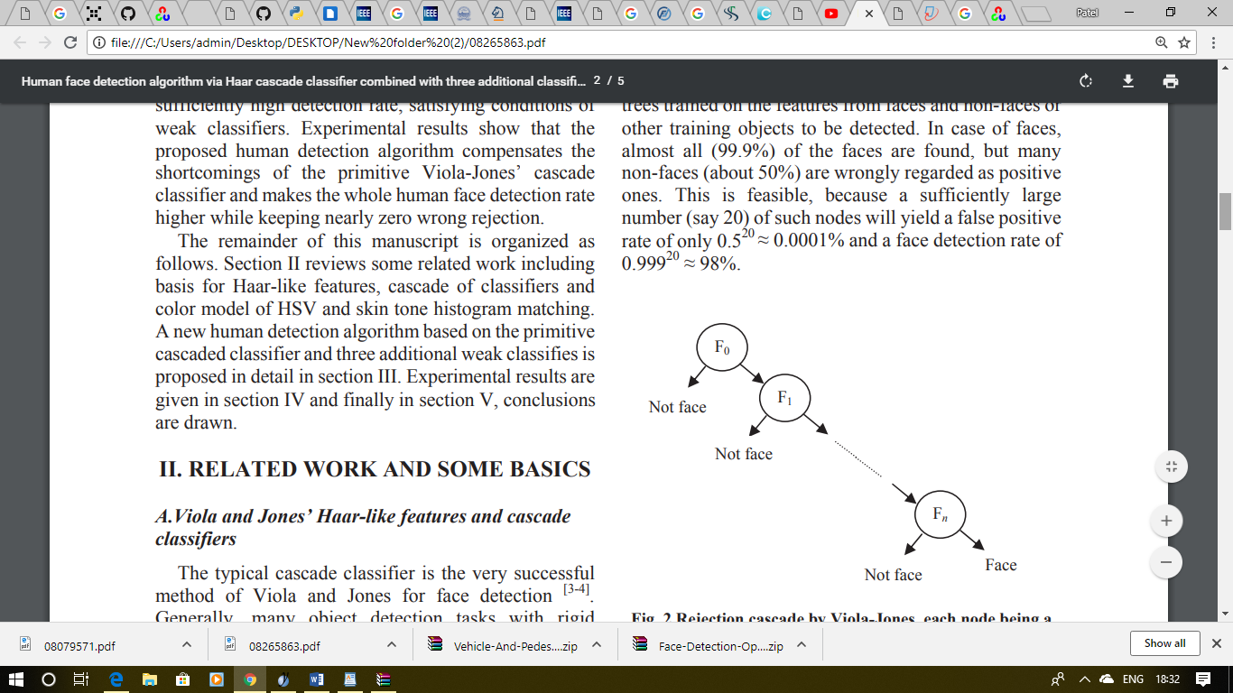
2.4 Proposed work contribution
On account of the aforementioned background and discussions, a new human face detection algorithm is proposed to implement a stronger whole detection system by appending three weak classifiers, i.e., a classifier based on skin tone histogram matching, a classifier based on eyes detection, and third, a classifier based on mouth detection.

3. Related Literatures
3.1 Existing work in the context of proposed work
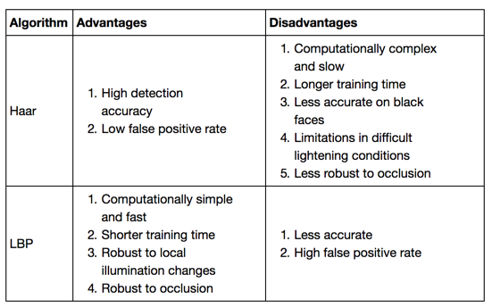
Face Detection is a critical advance in any face acknowledgment frameworks, to localize and separating face area from whatever is left of the pictures. There are numerous systems, which have been proposed from straightforward edge identification methods to propel strategies, for example, using design acknowledgment approaches. This paper assesses two strategies for confront location, her highlights and Local Binary Pattern highlights in view of discovery hit rate and recognition speed. The calculations were tried on Microsoft Visual C++ 2010 Express with OpenCV library. The test results demonstrate that Local Binary Pattern highlights are most productive and dependable for the usage of a continuous face location framework.
Facial acknowledgment advancements have developed quick over the most recent couple of years. Powerful facial location and distinguishing proof is vital today in the fields of social improvement, open wellbeing, national security and others [1]. The two sections of facial acknowledgment innovation are confront identification and face acknowledgment. The most entangled and subsequently difficult advance of face acknowledgment is confront identification which should be exceedingly precise and also effective execution savvy. Face identification involves social event of data, for example, size and position of the face from picture or video stream which is noted. Position of the nose, space between the eyes and a couple of different things are the principles administering the procedure of face identification. There is a pre-characterized manual standard example which encourages the procedure of sanctuary coordinating [2] and after that the pursuit window is utilized to investigate the other conceivable face territories. The elements like course, size and pivot of the face can influence this generally straightforward strategy which we just specified. In a video stream or a picture, confront recognition is executed for finding a human face and its postures. It is a standout amongst the most essential data handling approaches. Maybe a couple of the issues which are experienced while playing out the most well-known kinds of face location are as per the following: Complicated imaging conditions may make trouble recognize frontal area and foundation. Utilizing greater and better examples while preparing a decent format can be an answer. In any case, since this strategy depends on single RGB (Red Green Blue) camera without profundity data, it may prompt another issue. The face protest on the camera could be a genuine face or a photo of a face imprinted on a magazine or a paper [3]. Thus, in this strategy customary camera isn't substantial to discover the genuine face. The following part is the face acknowledgment process which comprises of social event of data from the face. The principle points of interest of face acknowledgment and biometric recognizable proof process lies in its effortlessness. Gathering of information can be effortlessly done by a camera which does not should be of high caliber. In this way the accumulation methodology is exceedingly helpful, planned and gear is effortlessly accessible. Different systems like Iris acknowledgment, unique mark recognizable proof require assent of individuals while in confront discovery and acknowledgment we don't have to exasperate others. Accordingly we can state this technique isn't just more straightforward, easy to use and advantageous but at the same time are mainstream in everyday life. In view of geometric data, skin shading and factual shape the present face acknowledgment calculation, framework can identify the objective face under any lighting condition. If there should be an occurrence of skin shading based discovery, foundation of the picture can cause obstruction with the typical handling and acknowledgment of the appearances. Post-handling of the picture perhaps unfavorably influenced if the face isn't accurately extricated from the foundation picture. Skin shading has a few focal points in examination with different highlights as skin shading isn't influenced by stance and size; paying little respect to whether the face is turning and the appearance changes, skin shading is constantly recognizable and furthermore it isn't delicate to course. This paper proposes a strategy for confront discovery utilizing Haar course classifier [4] . The classifier is prepared with positive (pictures with appearances) and negative (pictures without faces). At that point, a picture is filtered utilizing the classifier. In the event that Haar-like highlights are discovered, at that point a face is identified in the picture. The following stage is database creation utilizing a yml document. Despite the fact that skin shading technique is utilized broadly, a non-human face with comparable skin shading is hard to separate. Consequently, after the utilization of Haar-like component for confront identification, the nearby element acknowledgment, LBP (Local Binary Patterns) [5] technique is used for confront acknowledgment. LBP mirrors the subtle elements of the face attributes, concentrating on the portrayal of surface highlights. As we have said previously, however confront acknowledgment method is a helpful ID device yet this system is likewise powerless against a few sorts of assaults. These in advance of said highlights can be utilized to cross check and give more exact outcomes. However, the most requesting work is identification of disguised face in picture preparing field due to the elements like low goals of picture, enlightenment changes and development of servile, and so forth. In this day and age, confront identification and acknowledgment is broadly utilized in recognizing a man and observation frameworks. In confront acknowledgment, for instance, confront identification possesses the vast majority of the acknowledgment time and prompts a period imperative of the acknowledgment calculations. Consequently for continuous recognition framework, the critical issue here is speed improvement and time-intricacy decrease. The rest of the piece of the paper is sorted out in the accompanying way: Section II means all the related works directed in the field. Area III portrays the proposed technique that we have taken after. Segment IV is a depiction of the trials performed with the test results. Segment V contains a concise end.

Analysts Sang-Seol Lee et al. have built up an equipment based technique for human-robot association utilizing LBP. The Face Detection is finished by first resizing the picture taken after by age of LBP for recognizing execution and discovering specific instance of surface range in the picture and afterward utilizing AdaBoost-based 4 course groupings to choose FD areas with a related certainty esteem. The equipment center of FD has been utilized by the LBP-based calculation with an assortment of scale spaces, course prepare strategy. The principle highlights incorporate help of up to 24 scale spaces with variable scale step estimate. The base face discovery can be done on 22x24 pixel estimate. Another component includes the usage of shared memory structure and computation mode. The FD equipment needs a great deal of memory to store the dim pictures. Consequently the picture dataset needs an outside memory. The pictures are put away in FIFO arrange. The FD essentially utilizes LBP age and AdaBoost based Haar Classifier techniques to recognize faces. The FD equipment IP needs huge recollections for the dim picture and parameters for certainty computation. For a 24-bit VGA picture its dim picture requires a memory size of 2.5 MB and for that outside memory is required. Face Detection and Authentication utilizing LBP and BSIF [7] Researchers Naveen S et al. have built up a strategy for perceiving and confirming a face to recognize a genuine face and a cover. The procedure initially recognizes the face locale from 2D pictures and the comparing profundity outline caught with a Kinect Camera which is extricated with course question indicator. The face is distinguished utilizing ViolaJones calculation for location and prepared datasets for discovery. Nearby and worldwide highlights from the face are distinguished utilizing a course indicator. The worldwide highlights are used for confront acknowledgment. Neighborhood highlights are utilized for recognizing a 3D cover from the genuine face. Phantom discovery from the eye locale and figuring the surface region of the nose provides some insight about the nearness of a cover. The highlights acquired from 2D and profundity classifier are contribution to a classifier for arrangement. An outstanding Eucledian remove is utilized for ascertaining the separation between the test and reference information. This information is then utilized for validation. The method followed in this paper utilizes worldwide highlights for acknowledgment and nearby highlights for validation. The blend of these two highlights gives a low HTER of 7.65%.
3.2 Limitations of the existing work
The first LBP administrator names the pixels of a picture with decimal numbers, which are called LBPs or LBP codes that encode the neighborhood structure around every pixel. It continues in this manner, as Each pixel is contrasted and its eight neighbors in a 3 ×3 neighborhood by subtracting the inside pixel esteem; the subsequent entirely negative qualities are encoded with 0,and the others with 1. For each given pixel, a parallel number is acquired by connecting all these twofold qualities a clockwise way, which begins from the one of its upper left neighbor. The relating decimal estimation of the produced double numberis at that point utilized for naming the given pixel. The determined binarynumbers are alluded to be the LBPs or LBPcodes. One constraint of the essential LBP administrator is that its small3×3 neighborhood can't catch overwhelming highlights with vast scale structures. To manage the surface at various scales, the administrator was later summed up to utilize neighborhoods of dif-ferent sizes [1]. A nearby neighborhood is deﬁned as an arrangement of testing focuses equitably divided on a circle, which is focused at the pixel to be named, and the examining focuses that don't fall inside the pixels are added utilizing bilinear interpolation,thus considering any sweep and any number of inspecting focuses in the area. Fig. 2 demonstrates a few cases of the ex-tended LBP (ELBP) administrator, where the documentation (P, R) indicate sa neighborhood of P inspecting focuses on a hover of span of R.
From the previously mentioned deﬁnition, the fundamental LBP musical drama tor is invariant to monotonic dim scale changes, which protect pixel force arrange in the nearby neighborhoods. The histogram of LBP names figured over a locale can be ex-ploited as a surface descriptor. The administrator LBP(P,R)produces 2pdifferent yield esteems, relating to 2pdifferent parallel examples framed by Ppixelsin the area. On the off chance that the picture is pivoted, these encompassing pixels in every area will move correspondingly along the edge of the circle, in this manner bringing about an alternate LBP esteem, aside from designs with just 1 and 0 s. With a specific end goal to evacuate turn impact, a revolution invariant LBP is proposed in
LBPri P, R = min{ROR(LBPP, R ,i)|,i=0,1, ..., P −1} where ROR(x, I) plays out a roundabout bitwise right move, on the P-bit number x,itimes. The LBPri (P,R)operator quantiﬁes happen rence insights of individual turn invariant examples, which relate to certain smaller scale includes in the picture; thus, the pat-terns can be thought to be a component identifier [1]. In any case, in [40], it was demonstrated that such a turn invariant LBP administrator does not really give discriminative data, since the event frequencies of the individual examples that are fused in LBPri (P,R)vary significantly and the rough quantization of the rakish spaces at 45◦intervals.
It has been demonstrated that specific examples contain more data than others. It is conceivable to utilize just a subset of 2pbinarypatterns to portray the surface of pictures. Ojala et al. named these examples uniform examples, which are meant as LBPU(P,R).
A LBP is called uniform, on the off chance that it contains at most two bitwisetransitions from 0 to 1 or the other way around when the relating bitstring is viewed as roundabout. For example, 00000000 (0 transi-tions) and 01110000 (2 changes) are both uniform, whereas11001001 (4 advances) and 01010011 (6 advances) are not.It is seen that the uniform examples represent around 90%of every one of the examples in a (8, 1) neighborhood, and around 70% ina (16, 2) neighborhood in surface pictures [1]. A comparable trial was directed on the FERET database, and it was discovered that 90.6% of the examples in a (8, 1) neighborhood, and 85.2% ina (8, 2) neighborhood are uniform. All the more as of late, Shan and Gritti veriﬁed the legitimacy of uniform examples to speak to tfaces from the perspective of machine learning. Speciﬁcally, they connected AdaBoost to choose the discriminative examples for outward appearance acknowledgment, and their tests showed that, by utilizing LBP(8,2) administrator, 91.1% of these chose pat-terns are uniform. Amassing the non uniform examples in toa single receptacle yields a LBP administrator with under 2plabels.For case, the quantity of marks with the area of 8pixels is 256 for the standard LBP, however 59 for LBPU2.It ought to be noticed that, when the first LBP administrator was proposed, Zabih and Woodﬁll presented a statistics change (CT) strategy ], which is fundamentally the same as LBP. What's more, CT maps the nearby neighborhood, which encompasses a pixel on to a paired string, and the main contrast amongst LBP and CT is the contrary request of bit string. Afterward, CT and its varieties were misused for facial picture investigation .
3.3 Research gaps from existing work
The C/C++ and MATLAB usage of the LBP administrator can be discovered online.LBP strategy has been produced as of late with substantial number of varieties for enhanced execution in various applications. These varieties center around various parts of the first LBP administrator: 1) change of its discriminative capacity; 2) upgrade of its vigor; 3) choice of its neighborhood; 4) augmentation to 3-D information; and 5) blend with different methodologies. In this segment, we survey ongoing varieties of LBP.
In most existing work, the information picture is isolated into little districts, from which LBP histograms are extricated, and the nearby histograms are additionally linked into a spatially upgraded highlight vector of the dimensionality of O (103). In addition, some ongoing varieties even increment the element vector length dramati-cally, for example, ELBP, VLBP, and Gabor-wavelets-based LBP. It isbelieved that the determined LBP-based component vector gives anovercomplete portrayal repetitive data, which could be lessened to be more minimized and discriminative. Moreover, when constructing ongoing frameworks, it is likewise wanted to have LBP-based portrayal with diminished full length. For every one of the reasons, the issue of LBP include determination has as of late been tended to in numerous literary works. We order these methods into two classes: The ﬁrst one is to diminish the full length in view of a few standards (like uniform examples), while the other one endeavors include determination systems to pick the discriminative examples. The two streams have their own benefits and disadvantages: the ﬁrst one is basic, yet has constrained element choice capacity; in actuality, the second one has a bette rfeature-determination limit, yet as a rule requires ofﬂine preparing that could be computationally costly.
3.4 Objectives of the proposed work
Object Detection using Haar feature-based cascade classifiers is an effective object detection method proposed by Paul Viola and Michael Jones in their paper, "Rapid Object Detection using a Boosted Cascade of Simple Features" in 2001. It is a machine learning based approach where a cascade function is trained from a lot of positive and negative images. It is then used to detect objects in other images.
Here we will work with face detection. Initially, the algorithm needs a lot of positive images (images of faces) and negative images (images without faces) to train the classifier. Then we need to extract features from it. For this, Haar features shown in the below image are used. They are just like our convolutional kernel. Each feature is a single value obtained by subtracting sum of pixels under the white rectangle from sum of pixels under the black rectangle.
Now, all possible sizes and locations of each kernel are used to calculate lots of features. (Just imagine how much computation it needs? Even a 24x24 window results over 160000 features). For each feature calculation, we need to find the sum of the pixels under white and black rectangles. To solve this, they introduced the integral image. However large your image, it reduces the calculations for a given pixel to an operation involving just four pixels. Nice, isn't it? It makes things super-fast.
But among all these features we calculated, most of them are irrelevant. For example, consider the image below. The top row shows two good features. The first feature selected seems to focus on the property that the region of the eyes is often darker than the region of the nose and cheeks. The second feature selected relies on the property that the eyes are darker than the bridge of the nose. But the same windows applied to cheeks or any other place is irrelevant. So how do we select the best features out of 160000+ features. It is achieved by Adaboost.
For this, we apply each and every feature on all the training images. For each feature, it finds the best threshold which will classify the faces to positive and negative. Obviously, there will be errors or misclassifications. We select the features with minimum error rate, which means they are the features that most accurately classify the face and non face images.
The final classifier is a weighted sum of these weak classifiers. It is called weak because it alone can't classify the image, but together with others forms a strong classifier. The paper says even 200 features provide detection with 95% accuracy. Their final setup had around 6000 features. (Imagine a reduction from 160000+ features to 6000 features. That is a big gain).
So now you take an image. Take each 24x24 window. Apply 6000 features to it. Check if it is face or not. Wow.. Isn't it a little inefficient and time consuming? Yes, it is. The authors have a good solution for that.
In an image, most of the image is non-face region. So it is a better idea to have a simple method to check if a window is not a face region. If it is not, discard it in a single shot, and don't process it again. Instead, focus on regions where there can be a face. This way, we spend more time checking possible face regions.
For this they introduced the concept of Cascade of Classifiers. Instead of applying all 6000 features on a window, the features are grouped into different stages of classifiers and applied one-by-one. (Normally the first few stages will contain very many fewer features). If a window fails the first stage, discard it. We don't consider the remaining features on it. If it passes, apply the second stage of features and continue the process. The window which passes all stages is a face region. How is that plan!
The authors' detector had 6000+ features with 38 stages with 1, 10, 25, 25 and 50 features in the first five stages. (The two features in the above image are actually obtained as the best two features from Adaboost). According to the authors, on average 10 features out of 6000+ are evaluated per sub-window.
So this is a simple intuitive explanation of how Viola-Jones face detection works. Read the paper for more details or check out the references in the Additional Resources section.
Haar-cascade Detection in OpenCV
OpenCV comes with a trainer as well as detector. If you want to train your own classifier for any object like car, planes etc. you can use OpenCV to create one. Its full details are given here: Cascade Classifier Training.
Here we will deal with detection. OpenCV already contains many pre-trained classifiers for face, eyes, smiles, etc. Those XML files are stored in the opencv/data/haarcascades/ folder. Let's create a face and eye detector with OpenCV. First we need to load the required XML classifiers. Then load our input image (or video) in grayscale mode.
import numpy as np
import cv2 as cv
face_cascade = cv.CascadeClassifier('haarcascade_frontalface_default.xml')
eye_cascade = cv.CascadeClassifier('haarcascade_eye.xml')
img = cv.imread('sachin.jpg')
gray = cv.cvtColor(img, cv.COLOR_BGR2GRAY)
Now we find the faces in the image. If faces are found, it returns the positions of
detected faces as Rect(x,y,w,h). Once we get these locations, we can create a ROI
for the face and apply eye detection on this ROI (since eyes are always on the face.
faces = face_cascade.detectMultiScale(gray, 1.3, 5)
for (x,y,w,h) in faces:
cv.rectangle(img,(x,y),(x+w,y+h),(255,0,0),2)
roi_gray = gray[y:y+h, x:x+w]
roi_color = img[y:y+h, x:x+w]
eyes = eye_cascade.detectMultiScale(roi_gray)
for (ex,ey,ew,eh) in eyes:
cv.rectangle(roi_color,(ex,ey),(ex+ew,ey+eh),(0,255,0),2)
cv.imshow('img',img)
cv.waitKey(0)
cv.destroyAllWindows()
4. Proposed Methodology (Framework)
4.1 Method and approaches
In the past years a lot of effort has been made in the field of face detection. The human face contains important features that can be used by vision-based automated systems in order to identify and recognize individuals. Face location, the primary step of the vision-based automated systems, finds the face area in the input image. An accurate location of the face is still a challenging task. Viola-Jones framework has been widely used by researchers in order to detect the location of faces and objects in a given image. Face detection classifiers are shared by public communities, such as OpenCV. An evaluation of these classifiers will help researchers to choose the best classifier for their particular need. This work focuses of the evaluation of face detection classifiers minding facial landmarks.
I. INTRODUCTION LTHOUGH recognizing an individual by the face is an easy task for humans, it is a challenge for vision-based automated systems. It has been an active research area involving several disciplines such as image processing, neural networks, statistics, pattern recognition, anthropometry and computer vision. Vision-based automated systems can apply facial recognition and facial identification in numerous commercial applications, such as biometric authentication, human-computer interaction, surveillance, games and multimedia entertainment. Unlike other biometrics, face recognition is non-invasive, and does not need physical contact of the individual with the system, making it a very acceptable biometric. Vision-based automated systems applied to face recognition can be divided into 4 steps: face detection, image pre-processing, feature extraction and matching [1]. Face detection is a hard task, once faces form a similar class of objects and their features, such as eyes, mouth, nose and chin, have, in general, the same geometrical configuration. The captured image of the face may be pre-processed to overcome illumination variations. Feature extraction is the process where a geometrical or vectorial model is obtained gathering important characteristics presented on the face. Feature extraction can be divided into 3 approaches: holistic, feature-based and hybrid. Principal component analysis, fisher discriminant analysis and support vector machine are examples of holistic approach. Feature-based approach is based on geometrical relation of the facial features. applied active shape model, gathering important information presented in some of the facial features. Statistical classifiers such as Euclidian distance, Bayes classifier, Mahalanobis distance and neural classifiers can be used to compare the characteristic vector with other classes (individuals) in the matching step. Face detection has been improved in terms of speed with the application of haar-features with the contribution of the ViolaJones object detection framework. Implementations of this framework, such as OpenCV, provide different face classifiers created by authors that used different datasets into their training. The performance and reliability of these classifiers vary a lot. evaluated the performance of some classifiers and also tested their accuracy. This paper focuses on evaluating facial classifiers regarding facial features contained in the found face. We propose a method using different scores given to each facial feature contained in the located face. Two different face databases (FEI database and yale face database) were used to evaluate 10 face classifiers.
Dynamic Object identification is an essential component of software engineering. The advantages of protest discovery is anyway not constrained to somebody with a doctorate of informatics. Rather, question identification is becoming further and more profound into the basic parts of the data society, loaning some assistance wherever required. This paper will address one such probability, in particular the assistance of a Haar-course classifier. The fundamental spotlight will be working on this issue investigation of a vehicle recognition and tallying framework and the conceivable outcomes it will give in a semi-encased zone - both the factual kind and furthermore for the normal man. The objective of the framework to be created is to additionally straightforwardness and enlarge the regular piece of our lives.
1. Presentation and hypothesis
1.1 Computer vision
Computer vision is a field of informatics, which trains PCs to see. It is a way PCs accumulate and translate visual data from the encompassing condition. Generally the picture is first handled on a lower level to upgrade picture quality, for instance expel commotion. At that point the photo is handled on a more elevated amount, for instance recognizing examples and shapes, and consequently endeavoring to decide, what is in the photo.

1.2 Object recognition
Object discovery is ordinarily alluded to as a strategy that is in charge of finding and recognizing the presence of objects of a specific class. An expansion of this can be considered as a strategy for picture preparing to distinguish objects from advanced pictures.
1.3 Simple identification by shading
One approach to do as such, it to just characterize questions in pictures as per shading. This is the primary variation utilized in, for instance, automated soccer, where distinctive groups have amassed their robots and clash with different groups. Notwithstanding, this shading coded approach has its drawbacks. Trials in the global RoboCup rivalry have demonstrated that the lighting conditions are to a great degree unfavorable to the result of the amusement and even the smallest surrounding light change can demonstrate deadly to the achievement of either group. Members need to recalibrate their frameworks various occasions even on a similar field, on account of the minor encompassing light change that happens with the season of day. Obviously, this kind of location isn't reasonable for most true applications, in view of the consistent requirement for recalibration and upkeep.
1.4 Introduction of Haar-like highlights
A more modern strategy is accordingly required. One such strategy would be the location of items from pictures utilizing highlights or particular structures of the protest being referred to. Be that as it may, there was an issue. Working with just picture powers, which means the RGB pixel esteems in each and every pixel in the picture, made component count rather computationally costly and along these lines moderate on generally stages. This issue was tended to by the socalled Haar-like highlights, created by Viola and Jones based on the proposition by Papageorgiou et. al in 1998. A Haar-like component thinks about neighboring rectangular districts at a particular area in a recognition window, aggregates up the pixel forces in every locale and computes the distinction between these entireties. This distinction is then used to classify subsections of a picture. A case of this would be the recognition of human countenances. Normally, the zones around the eyes are darker than the zones on the cheeks. One case of a Haar-like element for confront location is in this manner an arrangement of two neighboring rectangular regions over the eye and cheek locales.
1.5 Cascade classifier
The course classifier comprises of a rundown of stages, where each stage comprises of a rundown of frail students. The framework recognizes protests being referred to by moving a window over the picture. Each phase of the classifier marks the particular area characterized by the present area of the window as either positive or negative – positive implying that a protest was found or negative implies that the predefined question was not found in the picture. On the off chance that the naming yields a negative outcome, at that point the characterization of this particular locale is thusly entire and the area of the window is moved to the following area. In the event that the marking gives a positive outcome, at that point the district moves of to the following phase of arrangement. The classifier yields a last decision of positive, when every one of the stages, including the last one, yield an outcome, saying that the protest is found in the picture.
A genuine positive implies that the protest being referred to is in reality in the picture and the classifier marks it all things considered – a positive outcome. A false positive implies that the marking procedure erroneously decides, that the question is situated in the picture, in spite of the fact that it isn't. A false negative happens when the classifier can't recognize the real protest from the picture and a genuine negative implies that a nonobject was accurately classifier as not being the protest being referred to. So as to function admirably, each phase of the course should have a low false negative rate, in light of the fact that if the real question is named a non-protest, at that point the grouping of that branch stops, with no real way to rectify the misstep made. Notwithstanding, each stage can have a moderately high false positive rate, in light of the fact that regardless of whether the n-th arrange characterizes the non-question as really being the protest, at that point this mix-up can be settled in n+1-th and ensuing phases of the classifier.
4.2 Metrics and measurements
In image processing, object recognizing means the presence of an object belonging to a certain predefined class, within a static frame (image), or in a video frame (streaming video).
Objects can be classified into simple and complex objects. For simple objects, recognition of objects is equivalent to determining the edges (edge detection), of specific color regions, textures, shapes, etc. In the case of complex objects, such as human face, their detection is done using different. methods based on learning specific features (classifiers).
Viola and Jones proposed a new approach for object recognition, using a cascade of classifiers to describe the object to be recognized. The algorithm proposed by the two researchers aimed, firstly, at human face detecting, but classifiers can describe other classes of objects that can be recognized as well. To implement the object recognition software module, an Open CV image processing library has been used.
In programming, a library is a collection of routines that have already been tested, and put into a format that allows their use in other applications too, with no need of rewriting them. OpenCV library is free for both commercial and research use. The library is designed to run on multiple operating systems: Mac OS X, Windows and Linux . The main objective of the OpenCV library is to achieve real-time processing, both image and frame, from a video sequence. For this reason, image processing algorithms are optimized by the experts from Intel. OpenCV contains over 400 functions, covering 28 areas of research in image processing and analysis, thus being highly flexible.
The content of the library is created as follows: when a researcher has discovered a new algorithm, he sends it to Intel, where it is analyzed, optimized, and adapted to take advantage of special support processors for MMX multimedia (Matrix Math eXtension), and SSE (Streaming SIMD Extensions). That algorithm is to be included in the next version of the library, which will be launched. Processors that are currently marketed benefit from MMX and SSE technology, and therefore OpenCV is a very good choice for analysis and image processing, due to its optimization for the hardware structure of the processors. OpenCV Library was launched in 2001, and since then it has grown to encompass all known image processing algorithms, providing a complete tool for creating applications in this area.
OpenCV library has the following features:
• C / C + + library free for image processing.
• It is optimized and developed for real-time applications.
• It does not a operating system dependent.
• Generic functionality for loading, saving and getting pictures/video.
• API (Application Programming Interface) support for programming, low and high level.
• Provides Intel Integrated Performance Primitives interface (API) with specific optimizations at the processor level.
The main features of the OpenCV library are:
• Handling an image data (allocation, de-allocation, copying, saving, conversion).
• Images and video stream Input / Output (both filelevel and device-level - web-cam, camcorders, digital cameras).
After the object has been identified, the next step is to measure it, in order to pre-configure the gripper, and generate its 3D model.To determine the size of the detected objects, a method based on finding the report between the actual object size in millimeters, and its size in pixels, is used. In the case of a static sequence, each pixel can be associated with size in millimeters, as seen in fig. 9. However, gripping strategy requires object analysis while the gripper is moving to the object. Thus, the software module will always capture video frames to a resolution that is known (640 * 480 pixels) where the size of the object detected, in pixels, varies depending on the distance of the frame capture. The closer the video device will be to the object, the more it will tend towards the maximum size of the video frame. To assign a standard, before the actual measurement of an object, calibration is needed that involves a known-size object (a standard) in the zero position of the video device.
By this procedure, the ratio of the object size between millimeters and pixels, is assigned. Based on the detected standard, the variation of the pixel size can be found, according to the video capture distance. The process is illustrated in fig. 8. The value of the mm / pixel ratio can help in obtaining crucial information in the gripping process: the distance to the object (see & 2). Thus, the distance covered between two points helps in the calibration process of the measurement system, and in setting the mm / pixel ratio. In real environment, the distance covered along Y axis can be found from the robotic arm controller. will have the gripper attached, and in virtual environment, the 3D model of the object, recognized and measured, will be generated. The object is classified (sphere, parallelepiped, cylinder or cone) and its size in pixels is calculated.
To solve this phase Open Inventor software module developed by Silicon Graphics Inc. (SGI) was selected. One of the main reasons why this format was chosen is that it allows a complete description of the 3D scene graphs with polygons rendered in the form of objects. Open Inventor also includes lighting facilities, descriptions of materials and textures and special effects. An Open Inventor file has the extension iv and describes a text file in ASCI format (format that uses letters and characters in the English alphabet) that illustrates through nodes and elements the 3D scene. Thus, Open Inventor format can be viewed as a descriptive language of a virtual scene.
In addition, having a standard description of virtual scene, interoperability between applications that have an Open Inventor files interpreter implemented can be achieved.

4.3 Overview organization of the proposed work (Context Diagram)

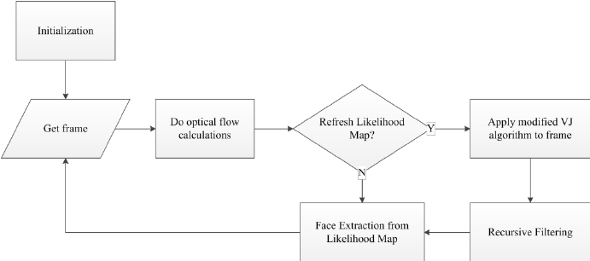
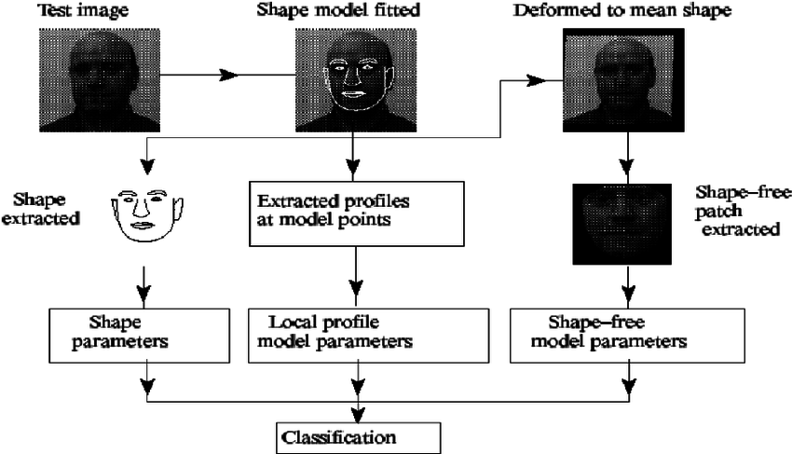

4.4 Data Analysis methods
Wavelet Transform is a flag handling system was produced as a technique to acquire concurrent, have high goals recurrence and time, Wavelet Transform (WT) too for picture preparing and packing from the Fourier change (FT) and has been generally used to flag handling application. The WT presents a change over the STFT and has multidimensional characters and can alter their scale to the idea of a flag highlights. Singularities and sporadic structures in flag waveform frequently convey essential data from an informatics-theoretic perspective. Wavelet Transform (WT) is Analyzes gives a sort of scientific capacities in zoom out or zoom in, on those intriguing structures of sound and picture . Wavelets can be can catch deterministic highlights and orthonormal. Hence, WT can deteriorate a flag into interpretation parameters and restricted commitments marked by socalled enlargement. These parameters speak to the data of various recurrence part contained in the investigated signals. Wavelet change or wavelet examination is an as of late created numerical instrument for some issues. One of the prominent groups of wavelet is Haar wavelets. Haar wavelet work in truth the Daubechies wavelet of request 1. Because of its straightforwardness, the Haar wavelet had turned into a compelling device for tackling numerous issues emerging in numerous branches of sciences. Haar wavelet capacities have been utilized since year at 1910. It was presented by the Hungarian mathematician Alfred Haar.
A short prologue to the constant wavelet change (CWT) is introduced straightaway. For more points of interest regarding this matter, intrigued by these subjects, perusers can counsel in Lange et al. or different writings. Keeping in mind the end goal to manufacture a strong example coordinating strategy, we additionally connected the CWT in MS top recognition. As opposed to the calculation proposed by Mallatwe specifically apply the CWT over the crude range and use the data over the 1D CWT coefficients frameworks, which give extra data on how the CWT coefficients change over scales.
Dolphins family in well evolved creatures have great becoming aware of affectability. It is caused by a system framework faculties of hearing has been well. Dolphins can be becoming aware of snap sounds with frequencies extend 1-150 kHz .Previous research by taking a gander at a shriek sound vocalizations of dolphins and a clicking sound is . Vocalizations look into about stidulatory at any point finished with protest Guppy fis. In this article talk about haar wavelet technique to phantom examination constant wavelet change 1D utilizing shriek sound and position dolphins (Tursiops aduncus), dolphins estimated in hostage of safari stop, Cisarua, Indonesia. Information investigation in this exploration with MATLAB R2011a programming with haar wavelet strategy in flag preparing utilizing MATLAB R2011.
5. Implementation and Proposed System Results
5.1 Mathematical Foundation
The most instinctive answer for the issue of demonstrating faces is the geometric plan which enables the indicator to extend a tried picture onto an educated subspace and decide if it is near that subspace. The common activity with a preparation set, at that point, is to register a complex in Rn (from preparing pictures containing n pixels) from the most huge parts of the general face. This is an extremely fundamental plan, and is computationally difficult utilizations an adjustment of this plan to make a discovery plot utilizing Gaussian bunches in Rn .The essential thought of their identification demonstrate is utilizing a numerous mean Gaussian blend display for the two articles and non-objects. Clearly the space with low protest likelihood is the non-question space, so it is more precise to state that among the Gaussian protest bunches; contrarily weighted groups are put in order to enhance the meaning of the protest space. As far as the identification issue, these adversely weighted groups will be focused at pictures which can be confused for appearances, however are really not. Their execution utilizes six bunches every one of face and non-confront. Their learning strategy is fitting since extensive focal point of the identifier is on recognizing countenances and face-like non-faces. They utilize a bootstrapping methodology for making a non-confront preparing set comprising of just the most important non-faces (instead of a general non-confront preparing set, which would contain numerous pictures which are so clearly not faces that they hold little weight in the finder). Develop their face set in an extremely direct way (growing their informational collection with revolutions and responses).
5.2 Data Validation
1. Creating the Database:
The photo is gotten through a best quality camera in the midst of the class hours. Appearances of customers are recognized, divided and set away for check with database. After the productive match of countenances, the customer ID is showed up by the structure.
Our structure manages 3 divisions which are: -
The first is making a database of the customer; structure uses python code using opencv to set up a database of the individual sitting before the camera in various tendencies and positions. This is only a solitary time framework. The photos got and divided will be added to the database for the incessant invigorate of the database.

The second one is confront distinguishing proof; a better quality camera is used than catch the photo of the whole class. The got picture is then separated into appearances using an exceptional estimation i.e. haarcascades formed by viola jones for eyes and face revelation. This figuring discards the issues of lighting up, insurgency and scaling somewhat.

The third one is confront acknowledgment; structure uses adjacent twofold precedent (LBP) to see the face. In this the face is gotten and parceled into different pieces. Histograms of each square is made and piece histogram are moved into face picture. The main LBP executive labs the pixels of picture by thresholding the pixels with within pixel. If the estimation of the neighbor pixel is more imperative than or equal to within pixel, the neighbor pixel is consigned as 1 else 0.
2. Capturing the Image:
A webcam is presented in the compact PC which is used to take photos of the customer. The camera can be physically controlled or redone as per the choice of the customer. Resulting to getting the photo, it will be sent to the structure for moreover planning.
3. Face detection and segmentation using Haar cascades
Once the system gets the data picture, it will be dealt with and each one of the faces present will be recognized using the haar course feature of OpenCV. The photo by then will be segmented to each one of the countenances present and will be secured in a record for that particular date.
4. Face recognition using LBP
When every one of the faces are fragmented, we will run the face recognition code. Each of the faces from the specific date organizer will be checked with the database utilizing the neighborhood twofold example calculation and if comparative face is discovered the photograph will be added to the database for better productivity in future.
Code for face_datasets
import cv2
vid_cam = cv2.VideoCapture(0)
face_detector = cv2.CascadeClassifier('haarcascade_frontalface_default.xml')
face_id = 2
count = 0
while(True):
image_frame = vid_cam.read()
gray = cv2.cvtColor(image_frame, cv2.COLOR_BGR2GRAY)
faces = face_detector.detectMultiScale(gray, 1.3, 5)
for (x,y,w,h) in faces:
cv2.rectangle(image_frame, (x,y), (x+w,y+h), (255,0,0), 2)
count += 1
cv2.imwrite("datasets/User." + str(face_id) + '.' + str(count) + ".jpg", gray[y:y+h,x:x+w])
cv2.imshow('frame', image_frame)
if cv2.waitKey(100) & 0xFF == ord('q'):
break
elif count>400:
break
vid_cam.release()
cv2.destroyAllWindows()

Code for face_recognition
import cv2
import numpy as np
recognizer = cv2.face.LBPHFaceRecognizer_create()
recognizer.read('trainer/trainer.yml')
cascadePath = "haarcascade_frontalface_default.xml"
faceCascade = cv2.CascadeClassifier(cascadePath);
font = cv2.FONT_HERSHEY_SIMPLEX
cam = cv2.VideoCapture(0)
while True:
ret, im =cam.read()
gray = cv2.cvtColor(im,cv2.COLOR_BGR2GRAY)
faces = faceCascade.detectMultiScale(gray, 1.2,5)
for(x,y,w,h) in faces:
cv2.rectangle(im, (x-20,y-20), (x+w+20,y+h+20), (0,255,0), 4)
Id, conf = recognizer.predict(gray[y:y+h,x:x+w])
print(conf,"\t",Id)
if(Id == 1 and conf < 75):
Id = "Confirmed”;
else:
Id = "Unknown”;
cv2.rectangle(im, (x-22,y-90), (x+w+22, y-22), (0,255,0), -1)
cv2.putText(im, str(Id), (x,y-40), font, 2, (255,255,255), 3)

cv2.imshow('im',im)
if cv2.waitKey(10) & 0xFF == ord('q'):
break

cam.release()
cv2.destroyAllWindows()

Code for training
import cv2, os
import numpy as np
from PIL import Image
recognizer = cv2.face.LBPHFaceRecognizer_create()
detector = cv2.CascadeClassifier("haarcascade_frontalface_default.xml");

path = 'datasets'

def getImagesAndLabels(path):
imagePaths = [os.path.join(path,f) for f in os.listdir(path)]
faceSamples=[]
ids = []
for imagePath in imagePaths:
PIL_img = Image.open(imagePath).convert('L')
img_numpy = np.array(PIL_img,'uint8')
id = int(os.path.split(imagePath)[-1].split(".")[1])
faces = detector.detectMultiScale(img_numpy)
for (x,y,w,h) in faces:

faceSamples.append(img_numpy[y:y+h,x:x+w])
ids.append(id)

return faceSamples,ids

faces,ids = getImagesAndLabels('datasets')
recognizer.train(faces, np.array(ids))
recognizer.write('trainer/trainer.yml')

5.3 Tools Used
We will utilize Haar Cascades calculation for our face recognition framework which separates the picture into rectangular sections in light of the entirety of the pixel powers between adjoining districts on a picture. For instance, let us say we have a picture database with human appearances. It is a typical perception that among all faces the area of the eyes is darker than the district of the cheeks. In this way, a typical Haar highlight for face recognition is an arrangement of two nearby square shapes that lie over the eye and the cheek locale.
Proposed Modules/Architecture
- Face detection module – Collects frontal face images and creates a database
- Training Module – Trains the database using LBPH algorithm
- Face Recognition module – Detects a frontal face image and checks whether it is present in the database or not.
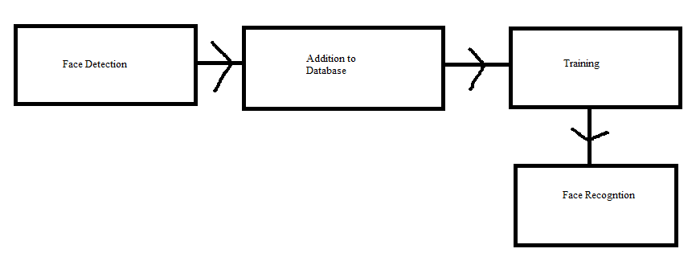

5.4 Illustrations of Results
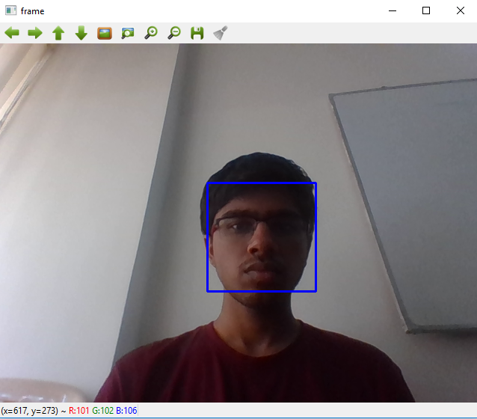
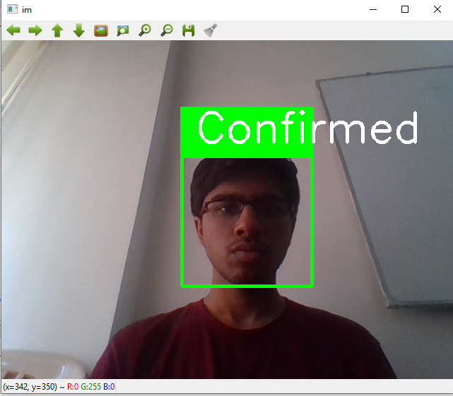

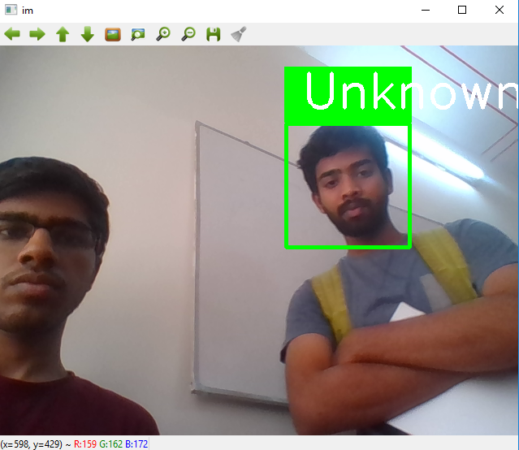

6. Results and Discussions
The task ends up being greatly precise and utilizes the Euclidean Distance as a proportion of exactness. For pictures under different types of enlightenment and facial introductions it perceives the pictures precisely up to a separation proportion of 75. Any real fluctuation like radical change in enlightenment or introduction prompts a separation proportion of more than 75 which prompts misclassification and erroneous yield.

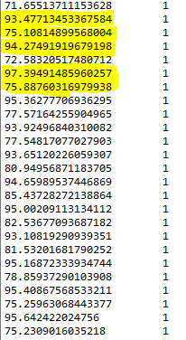
The left column shows the distance measure and the highlighted distance measures indicate misclassification.
The shrewd and robotized face location framework is demonstrated as a productive framework for client ID. This framework can be actualized in Attendance framework by the instructors. By utilizing this framework, the odds of phony participation and intermediaries can be lessened. There is a load of Biometrics Systems which can be utilized for overseeing participation, however the face recognition has the best execution. So, we have to actualize a solid and effective participation framework for classroom participation which can work for various face recognition at one time. Likewise, to execute this framework, no specific equipment is required. A camera gadget and an independent PC, database servers are adequate for developing the shrewd participation framework. With the assistance of a dissimilar mix of algorithms, this framework encourages us to accomplish wanted outcomes with better exactness and less time utilization.
Over the course of this survey we have learned multiple ways used for facial recognition and their advantages and disadvantages, the most prominent and popular methods are:
- Neural Networks
- Line Edge Maps
- Eigenfaces
- Hidden Markov Model
- Principle Component Analysis
Each of these methods are considered to be advantages in their own sense with more simple algorithms like Eigen faces and PCA considered to be efficient and simple to implement while more complex algorithms like Neural Networks and Line Edge Maps are considered to be optimal for feature extraction and accurate results.

7. Comparison with Existing study Results
RESEARCH PAPER  NAME | METHODOLOGY | Advantages | Disadvantages
A feature-based approach to face recognition | Topology graphs are used to find the relation between the features and a Simple Deterministic graph matching scheme which exploits the basic structure is used to familiar faces in the data base | It is easy to use in the real time applications and can differentiate people with an ease | Difficult to calculate the spacing between the features sometimes same spacing may occur for different people
Low dimensional procedure for the characterization of human faces | They are using Karhuanen-loeve expansion in pattern recognition and as factor or principal component analysis in the statistical literature | No specific advantages were mentioned in the papers. | Its classification time and training time is too expensive.
Emotion recognition from facial expressions based on multi-level classification | Principal Component Analysis (PCA) at level 1  and this is boosted by SupportVector Machines (SVMs) at level 2 | Ability to recognize non-membership to training set and robustness to cope with the variations of either different group sizes or group members | The correct classification rate for membership degrades significantly when size of members is small (< 20) due to limited training data set.
Compact multi-level representation of human faces for identification | NA | Focuses on local structure  of the manifold.  These methods project  face onto linear subspace spanned by the eigenface images. | These methods may fail to  adequately represent faces when  large variations in illumination facial  expressions and other factors occur
Practical face recognition and verification with WISARD | WISARD | The distance from face space is  orthogonal to the plane  of mean image, so may be  easily turned to Mahalanobis distances  with probabilistic interpretation | NA
Robust Alignment and Illumination by Sparse Representation | Sparse Representation and classification (SRC) algorithm  Deformable Sparse Recovery and Classification for Face Recognition | NA | The problem is that it is still  unclear how to select the neighbourhood size or assign optimal values for them
Learning human face detection in cluttered scenes | NA | Focuses on local structure  of the manifold.  These methods project  face onto linear subspace spanned by the eigenface images. The distance from face space is  orthogonal to the plane  of mean image, so may be  easily turned to Mahalanobis distances  with probabilistic interpretation | These methods may fail to  adequately represent faces when  large variations in illumination facial  expressions and other factors occur. Regarding to , applying kernel‐based nonlinear methods do not produce a  significant improvement comparing to linear methods. LLE, LLP and LBP brought simple and effective  way to describe neighbouring changes in face  description. Subspace approaches  were applied in DCV‐ and SVM‐based methods. Preserving the local structure between samples is the domain of NPP and ONPP methods.  The problem is that it is still  unclear how to select the neighbourhood size or assign optimal values for them

8.Conclusion
From this overview, where we experienced 20 examine papers about the diverse techniques for face acknowledgment, we saw some basic issues among strategies and repeating issues with the issue of face acknowledgment. The normal issues that we have recognized are:

• Adjustment to various levels of light.
• Adjustment to little and expansive changes in outward appearance and introduction.
• Large preparing time for strategies which can separate highlights precisely.

To handle the above given issues, we have distinguished a strategy which can handle every one of the three of those issues to satisfiable standard by utilizing two techniques for face identification, grouping and after that acknowledgment. The two strategies are Haar-Cascades for face location and Local Binary Patter Histogram for grouping and discovery. The reason we have utilized these strategies is on account of they chip away at relative distinction inside the diverse highlights of a face so the general enlightenment and outward appearance change doesn't influence the final product in light of the fact that the relative contrasts continue as before.
9. Future Work and Limitations
For a cutting edge on-the-fly question location calculation, view OpenTLD. It utilizes jumping boxes and arbitrary woods to find out around a protest after some time. We can likewise look at the matching_to_many_images.cpp test from OpenCV. It utilizes include descriptors to coordinate questions much like Google Goggles works. A related model to this is the bagofwords_classification.cpp test. It might be what you are searching for this situation. It utilizes highlight indicators (SURF, SIFT, etc...) to recognize protests and afterward group them by looking at the relative places of the highlights to a scholarly database of highlights. The latentsvmdetect.cpp may likewise be a decent beginning stage for us.

A portion of the conceivable restrictions of HAAR are

I. One known issue is the processing time in view of various classifier strategies.
II. The execution on RTOS stages can be dubious.
III. The multifaceted nature is unquestionably expanding (revile of dimensionality/dimensionality)
IV. Results are precarious to translate
V. A superior outcome (contrasted with an ideal single classifier) won't generally be accomplished.

